Machine Learning Project Report

# Definition

**Project Overview**

*Student provides a high-level overview of the project in layman’s terms. Background information such as the problem domain, the project origin, and related data sets or input data is given.*

The domain background for this project is the application of machine learning tools to predict prices for financial securities. For this project I took inspiration from a piece of code uploaded to machine learning platform Kaggle at <https://www.kaggle.com/kimy07/eurusd-15-minute-interval-price-prediction/data> and written by kimy07.

Our aim is to extend the analysis done in above code to a more granular (sub-second) dataset for EUR/USD with longer history (back to 2000). This should allow me to refine the model used by kimy07 and make better predictions.

From the literature on predicting financial security prices it appears the LSTM model (**L**ong **S**hort **T**erm **M**emory Network) can achieve better prediction capability compared to a simple Recurrent Neural Network and linear regression (http://colah.github.io/posts/2015-08-Understanding-LSTMs/) so we will use this approach. Other attempts at price prediction include bitcoin price prediction (<http://trap.ncirl.ie/2496/1/seanmcnally.pdf>), general evaluation of reinforcement learning algorithms on the foreign exchange market (<https://www.doc.ic.ac.uk/teaching/distinguished-projects/2015/j.cumming.pdf>), and stock market price prediction using LSTM specifically (<http://ieeexplore.ieee.org/document/7966019/>).

The dataset for this project is downloaded from <http://www.histdata.com/download-free-forex-data/?/ascii/tick-data-quotes> and consists of tick data - that is sub-second price quotes - for the EUR/USD currency pair since the beginning of 2000 up to the present day.

**Problem Statement**

*The problem which needs to be solved is clearly defined. A strategy for solving the problem, including discussion of the expected solution, has been made.*

The problem we will attempt to solve is price prediction based on historical tick data in the EUR/USD market.

We formulate this as a regression problem, as we try to predict future prices based on past information encoded in state variables, and those variables are continuous. An alternative formulation could be as a classification problem, but due to time constraints this was postponed.

The inputs for the problem are the millisecond date-time stamp, the bid and ask prices, as well as features derived from these such as open, close, high, low, bid-offer spread.

**Metrics**

*Metrics used to measure performance of a model or result are clearly defined. Metrics are justified based on the characteristics of the problem.*

The success of any solution will be measured by looking at the error of predicted out-of-sample next prices.

Given that the problem is stated as a regression, I will use the mean absolute error and the mean squared error as evaluation metrics. I would hope to achieve a MAE of less than 0.003, which would be an improvement over the Kaggle benchmark model.

# Analysis

**Data Exploration**

*If a dataset is present, features and calculated statistics relevant to the problem have been reported and discussed, along with a sampling of the data. In lieu of a dataset, a thorough description of the input space or input data has been made. Abnormalities or characteristics about the data or input that need to be addressed have been identified.*

The dataset is sourced from <http://www.histdata.com/download-free-forex-data/?/ascii/tick-data-quotes>. It contains for the EUR/USD currency pair tick by tick bid and ask price data for every day since 2000.

I will use date, bid and ask prices for this problem. Date is a millisecond datetime stamp, bid and ask are floating point numbers. Thus all three can be said to be continuous. The dataset has around 126 million rows. The outcome variable is the future price in the next period. Given I have many examples, I will split the data 80-10-10 into training, validation and testing.

To prevent the algorithm from using future information to predict previous prices, I will attach actual future prices as target labels to each historical window I use for training the model. I will experiment with different window ranges as training sets, each being a multiple of 15 minutes to allow comparison to the Benchmark model.

Regarding class balances, there should not be any price groups in this dataset – it is unlikely that there is a “preferred price” at which the currency pair trades. To stationarize the data, i.e. to give no particular preference to absolute price levels, we could predict returns instead of absolute price values. This also leads to balanced classes, as both positive and negative return between ticks are approximately equally likely. I will not attempt this due to time constraints, and instead focus on price prediction only.

**Exploratory Visualization**

*A visualization has been provided that summarizes or extracts a relevant characteristic or feature about the dataset or input data with thorough discussion. Visual cues are clearly defined.*

Below the performance history of eurusd:

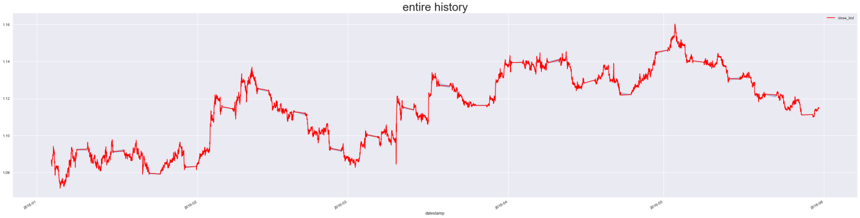

Y axis is price, x axis is datetime. There are periods where the price doesn’t move (weekends), this should be accounted for when building the model.

After building features, we find the following distributions:

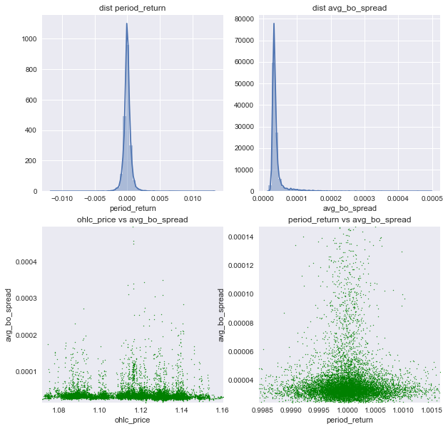

Returns seem evenly distributed, bid offer spreads are usually around 0.00005, prices are evenly distributed across the spectrum, returns around 0 seem to have the highest bid offer spreads. This makes sense as returns of 0 occur over the weekend where spreads would be wide given traders protect themselves against unforeseen market changes.

Next, we will check seasonality. We can see there is seasonality in the dataset, as the average bo spread changes with the hour, it seems highest and most spread out around 5 pm. The number of prices also varies with time, and to a smaller degree with the day of month. It seems around 5pm the least number of prices are observed, as well as around midnight.

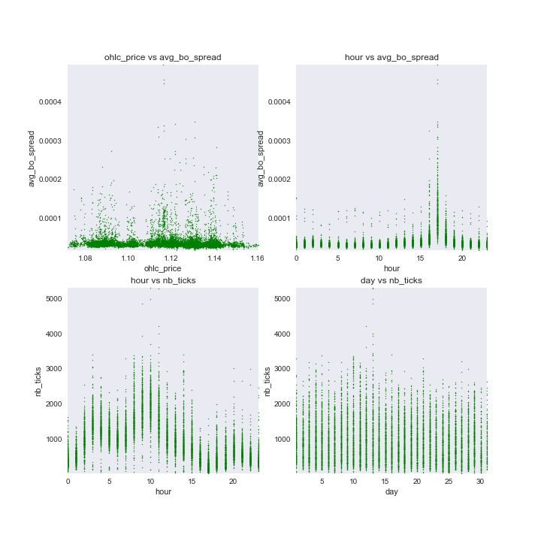

Further seasonality can be seen in the period return data and tick data on an hourly and weekday basis:

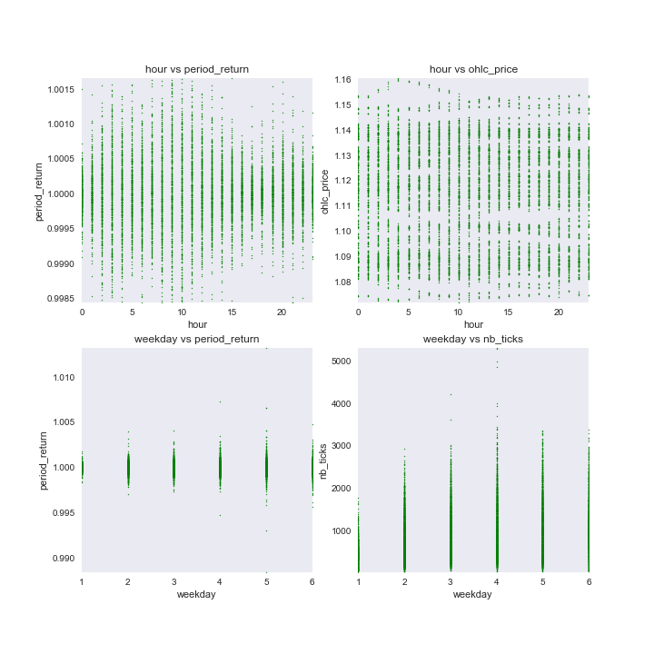

We can see here that weekday 4 (Thursday) has the largest variance in number of ticks, weekday 1 (Monday) clearly has a low absolute number of ticks. The period returns seems more narrow in the early hours and around 5pm, whereas there are no price patterns by the hour. This indicates that running return prediction might make for a more accurate model.

Finally, average bo spread is generally higher on Mondays:

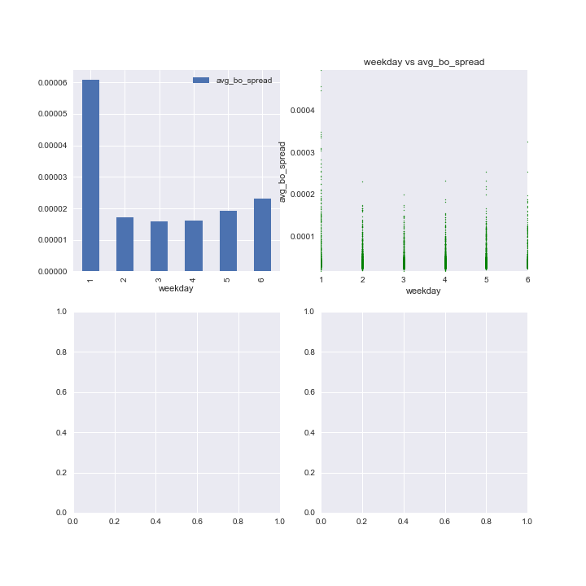

As a result of above, we have incorporated seasonality (hour, day, etc) as features so that any model could use them to improve prediction accuracy.

**Algorithms and Techniques**

*Algorithms and techniques used in the project are thoroughly discussed and properly justified based on the characteristics of the problem.*

Algorithms we tried are linear regression in order to get a first idea of how accurate a simple algorithm would be.

Next, PCA was used for dimensionality reduction and feature engineering as a preprocessing step for the subsequent neural network (LSTM). The idea was to remove correlated features that may have impacted linear regression.

We also tried a random forest regressor to help extract feature importances to see if there is an easy way to predict returns or prices. It seems the best feature was the previous close price, so direct historical dependency which indicated no pattern.

An LSTM network was used to make the final prediction as it could look at a timeseries of features and differentiate between recent and less recent values in order to find patterns.

**Benchmark**

*Student clearly defines a benchmark result or threshold for comparing performances of solutions obtained.*

As benchmark the Kaggle code created by kimy, a contributor on machine learning platform Kaggle, will be used: <https://www.kaggle.com/kimy07/eurusd-15-minute-interval-price-prediction/notebook>. The benchmark model attempted price prediction with bid price data on EUR/USD with a fairly coarse 15 minute observation window. We use the same interval using our own dataset to allow comparison of our results and get an idea if adding more features can improve the prediction accuracy.

# Methodology

**Data Preprocessing**

*All preprocessing steps have been clearly documented. Abnormalities or characteristics about the data or input that needed to be addressed have been corrected. If no data preprocessing is necessary, it has been clearly justified.*

To attempt a solution, the dataset is loaded into a sql database. Next data cleanliness is checked, to account for nulls, positive and negative outliers and to create a final, clean dataset.

The dataset is enriched by creating additional features for my state space, such as:

* returns
* bid-offer spreads
* period high, low, average

The tricky bit here is that although the prediction from the previous tick row is straightforward, as each feature can be used directly, using several tick rows to cover a 15 minute lookback window requires a decision how to use the features of each row. To address this, we will group the data into 15 minute intervals, with a number of aggregates to describe price behaviour during this time, such as:

* average
* period return
* open-high-low-close price (ohlc price)
* number of prices (called ‘ticks’) during period

In addition, due to feature correlation (ohlc price vs close price), PCA is used to extract the first dimension as a feature:

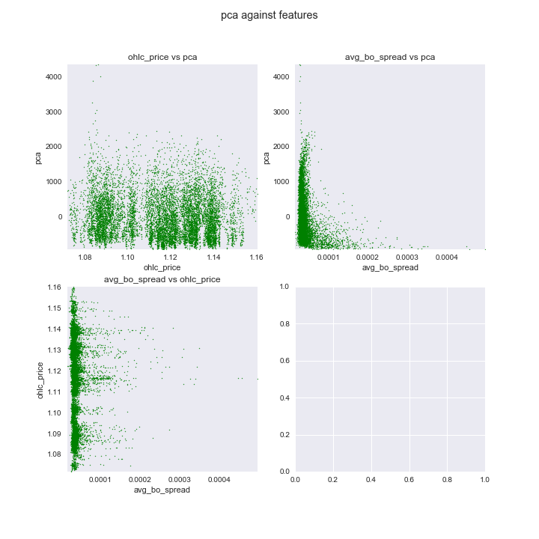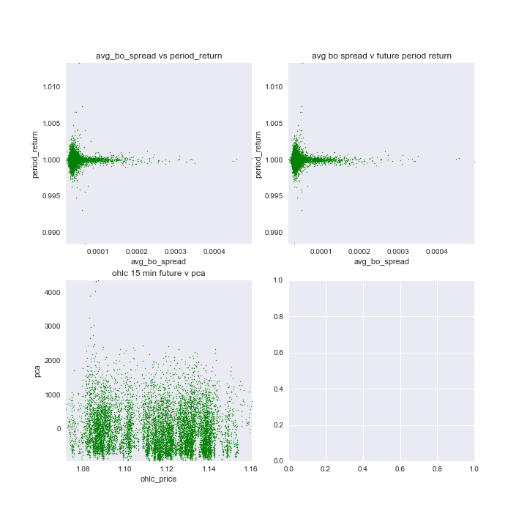

The results suggest that PCA does not add extra structure to the dataset. We also checked whether next period returns are correlated to any features but there seems no particular pattern.

Next we tried explicitly correlating features (year is greyed out as only two values are available):

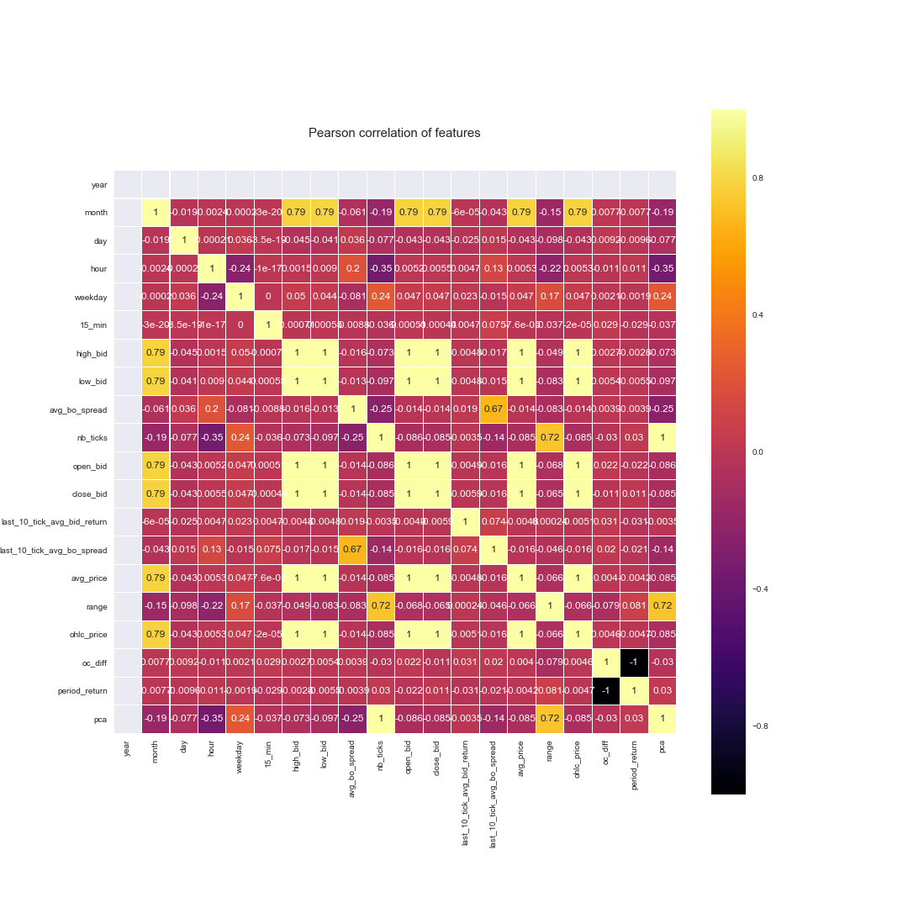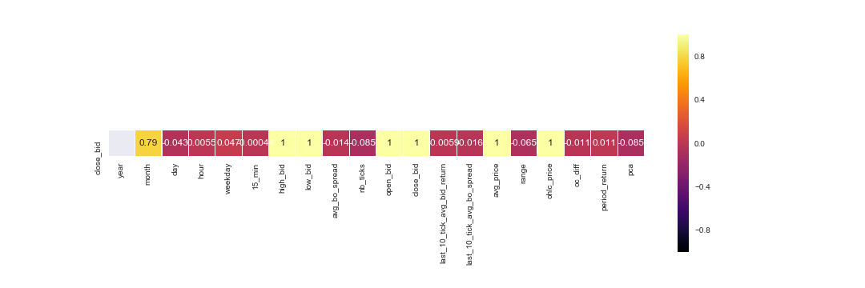

It can be seen that the best correlation to close is close itself, or else one of the other price composites for a 15 minute window. This is a trivial result, as the close price enters into those aggregates. Other observations are that the time and the number of ticks are correlated, which corroborates our initial findings that time provides structure to the data. Further, prices seem to have correlation with months, but given the short timeframe of data we use this will not be useful. We would have to look at several years to ensure month-price correlations are a consistent occurrence.

Random Forest:

A random forest regression suggests that the best feature to divide the dataset is the close price itself, by far:

Feature ranking:

close_bid 0.926392

ohlc_price 0.024249

avg_price 0.022592

high_bid 0.022400

low_bid 0.003085

open_bid 0.000675

last_10_tick_avg_bo_spread 0.000088

last_10_tick_avg_bid_return 0.000085

range 0.000064

avg_bo_spread 0.000060

pca 0.000056

nb_ticks 0.000053

oc_diff 0.000041

period_return 0.000039

hour 0.000037

day 0.000037

weekday 0.000021

15_min 0.000017

month 0.000009

Linear Regression:

Running linear regression to predict close price, this is the result:

oc_diff -0.204211

nb_ticks -0.096250

low_bid -0.017280

last_10_tick_avg_bo_spread -0.005564

avg_bo_spread -0.003196

avg_price -0.003091

last_10_tick_avg_bid_return -0.002060

weekday -0.000060

year 0.000000

month 0.000062

15_min 0.000098

day 0.000105

hour 0.000380

high_bid 0.012807

range 0.031856

pca 0.096251

period_return 0.185722

ohlc_price 0.199248

open_bid 0.300989

close_bid 0.505757

The main factors are the open close difference, the close bid, the open bid and the period return. PCA and the number of ticks get about 10% each. The other factors are marginal.

Finally, the choice of test set was a challenge. It had to be at the end of the timeseries, as else I would be using future information to predict past prices. My test set corresponds to the last 5 days of May 2016, some of which are a weekend so no price movement takes place. The test set contains about 1 percent of rows, but as the kaggle dataset and mine have slightly different lengths, I constrained the test set to contain exactly 149 rows, or 1% of the kaggle dataset to allow better comparison.

**Implementation**

*The process for which metrics, algorithms, and techniques were implemented with the given datasets or input data has been thoroughly documented. Complications that occurred during the coding process are discussed.*

The main coding difficulty was how to keep track of a long jupyter notebook. For that we added a table of contents plugin. To plot many different correlations, we wrote functions that would plot into a matplotlib subplot. Most algorithms were already available in various python libraries and have good documentation, so visualisation was the most difficult part. In addition, we had to save all intermediate steps, for example model weights, configuration, so that they could be reloaded in case I needed to check them again. We wrote a number of helper functions to do this, and organised the output file into a folder structure with names indicating the model version they belong to.

**Refinement**

*The process of improving upon the algorithms and techniques used is clearly documented. Both the initial and final solutions are reported, along with intermediate solutions, if necessary.*

Here a comparison of the errors of the different simulations. We chose MAE and MSE as errors, given we are trying to hit the exact price values. In addition, we calculate directional error metrics, to get an idea how often my prediction has the correct direction, and how often a misprediction results in a loss of more than 1 basis point (0.01 percent) of return to get an idea how often costly losses are caused by misprediction.

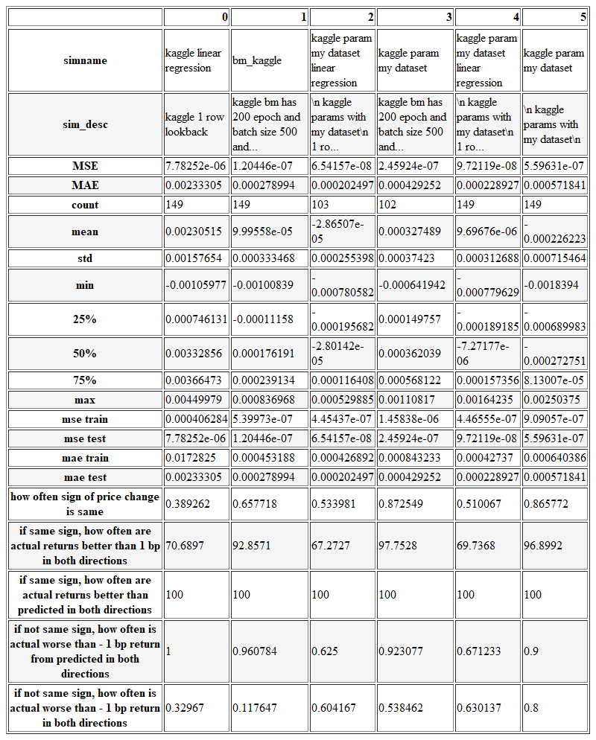

Kaggle Benchmark Model:

The kaggle benchmark LSTM model has a MAE of 0.00028 in close price prediction on the test set, and a directional accuracy of price changes of around 66 percent. If the direction matches, actual returns are always better than the returns implied by the predicted price. If direction does not match, all returns are always worse than predicted returns. So generally it seems the benchmark is biased to predict too small returns. The Kaggle linear regression benchmark shows MAE of 0.0023 and directional accuracy of around 40%, so considerably worse than the LSTM benchmark.

Rerunning the LSTM benchmark model with my dataset, and my additional features, grouped into 15 minute intervals, my MAE worsens to 0.00057, but directional accuracy improves to 86 percent. For linear regression, my MAE improves to 0.00021, and directional accuracy improves to 51 percent.

Rerunning the LSTM benchmark model with my dataset, I constrain the test set to be exactly 149 rows, just like the benchmark, to allow comparison as each observation would account for more than 1 percent of the accuracy.

It is possible given that my dataset has more features, it would probably require more training to converge and this might explain higher errors.

The benchmark LSTM model uses the following configuration:

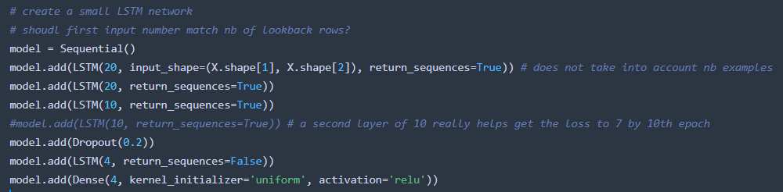

It is then rerun with a decaying learning rate:

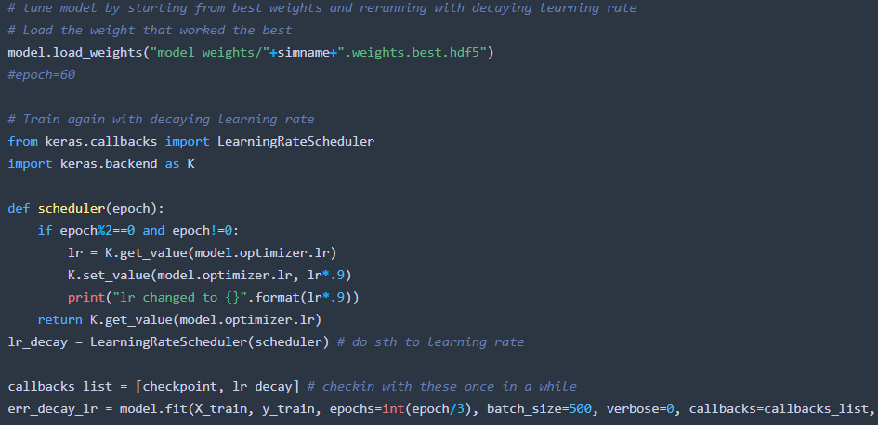

Parameter tuning LSTM model:

Next we tune the model parameters for the LSTM model, by changing batch size, number of epochs, lookback period, and the way data flows through the LSTM model. Here the results:

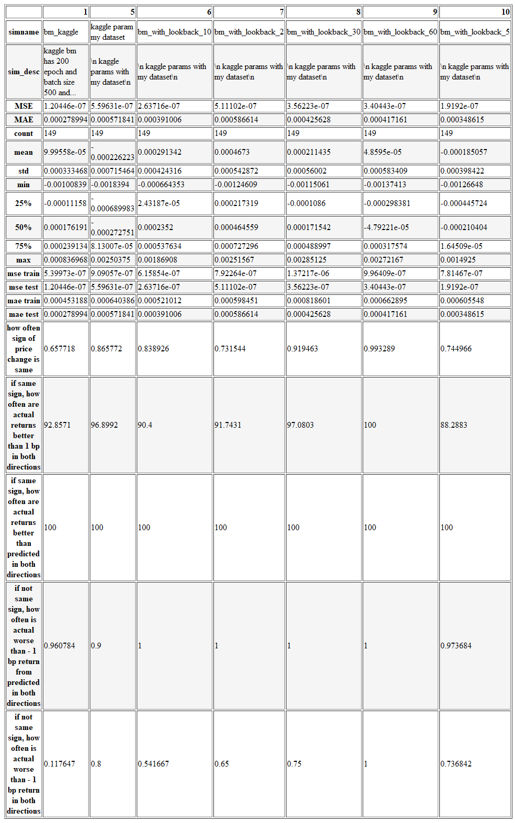

Reducing the lookback period from 20 intervals of 15 minutes to 10 yields and improvement in MAE to 0.00039, but decreases directional accuracy to 0.84. Running other lookback values shows that a longer lookback value gives better directional error whereas a shorter lookback gives better MAE.

Changing batch size from 500 makes MAE worse in both directions, but increasing epochs helps reduce MAE:

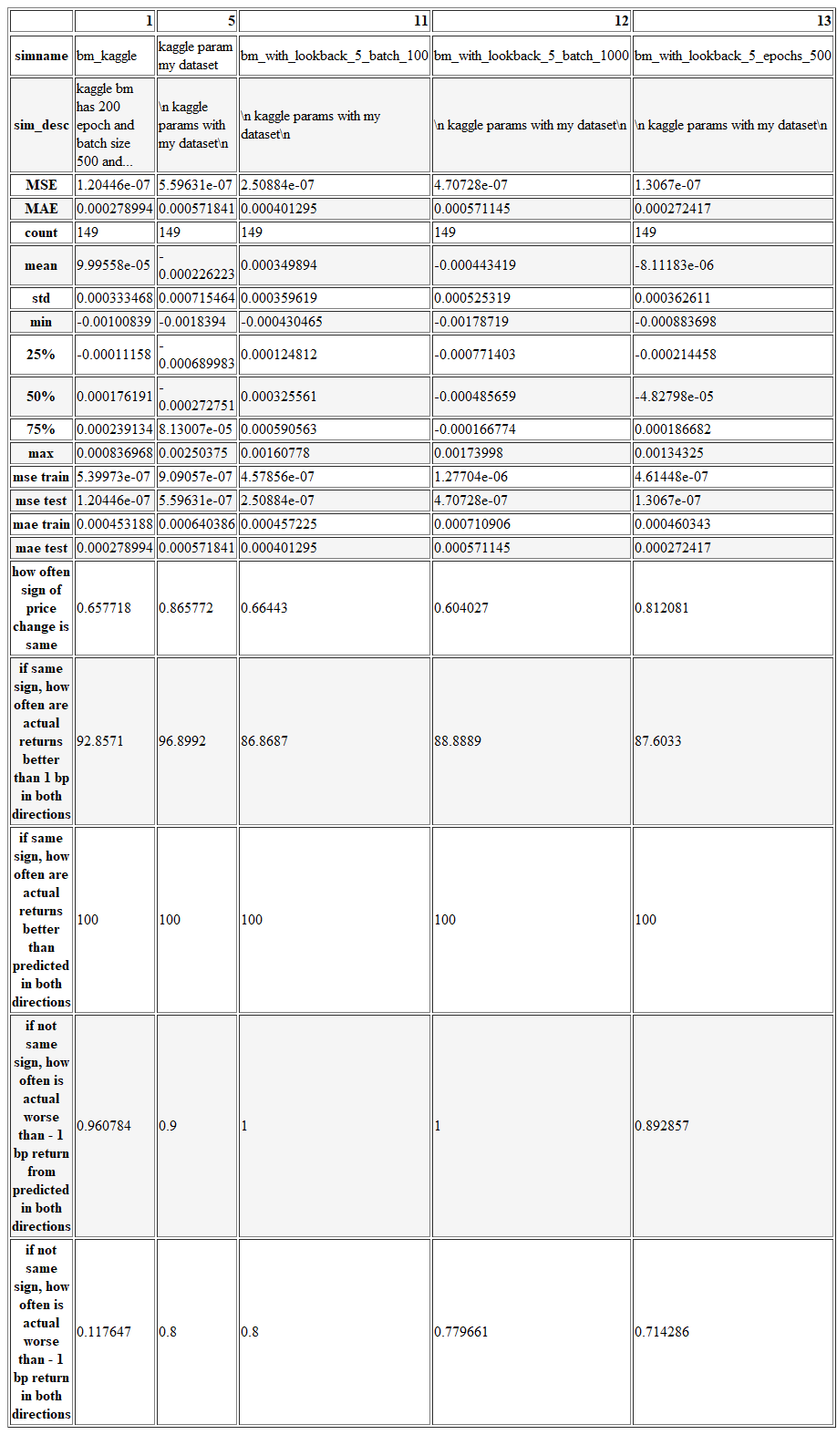

Increasing epochs too much increases MAE again, an indication that the model does not converge:

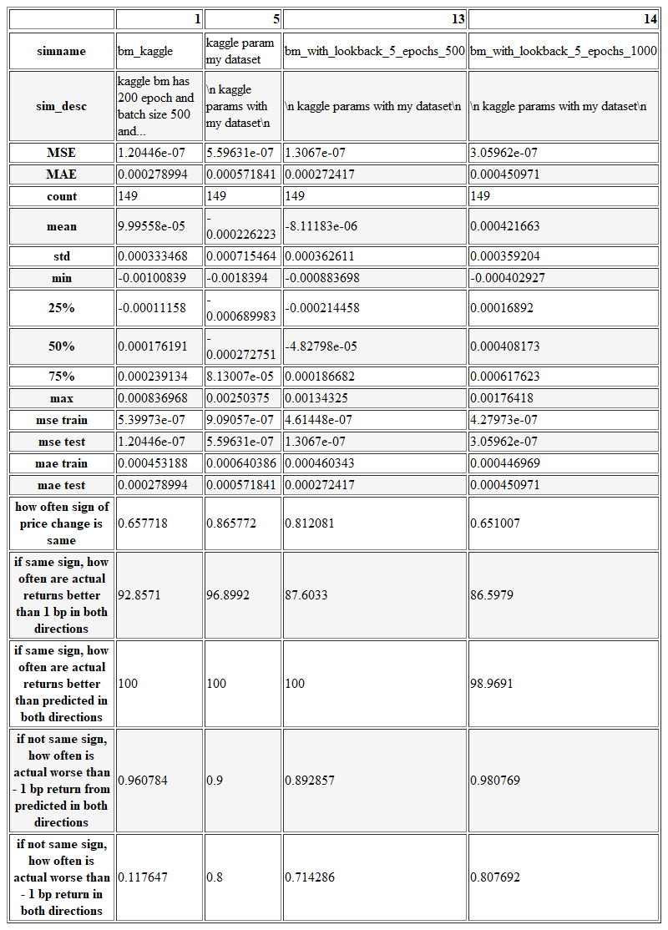

# Results

**Model Evaluation and Validation**

*The final model’s qualities — such as parameters — are evaluated in detail. Some type of analysis is used to validate the robustness of the model’s solution.*

The final Model is an LSTM Model with a lookback of 5 periods, running for 500 epochs in batch sizes of 500. The robustness is confirmed by above attempts to search the parameters space in the vicinity of the final solution and obtaining worse MAE. For statistical analysis see above tables.

**Justification**

*The final results are compared to the benchmark result or threshold with some type of statistical analysis. Justification is made as to whether the final model and solution is significant enough to have adequately solved the problem.*

The final solution represents a small improvement over the benchmark model. This is possibly down to a lack of explanatory parameters in the price history only – one might have to take into account other financial variables such as news. The MAE improved and the directional accuracy is better as well.

# Conclusion

**Free-Form Visualization**

*A visualization has been provided that emphasizes an important quality about the project with thorough discussion. Visual cues are clearly defined.*

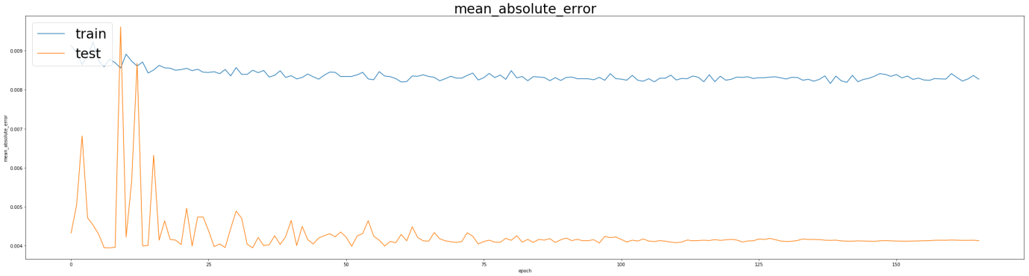

The above visualisation shows the MAE history for the final model. One can see that it initially oscillates and then settles at its final value long before we reach the last epoch. Thus one conclusion could be that the model is stuck in a minimum and cannot get out, or that I simply do not have enough information in my features to improve the MAE.

**Reflection**

*Student adequately summarizes the end-to-end problem solution and discusses one or two particular aspects of the project they found interesting or difficult.*

It was very interesting to investigate different properties of the dataset. It was difficult to get down the prediction error, possibly because I am solving for the wrong measure. A much more practical measure would be to predict whether I get the direction of the next price movement right, rather than its value. This would give less importance to small errors in value.

It was interesting to create my own error function and logging system, as well as a notebook than can run through in one go without needing human attention. This is very useful to quickly test a new parameter combination and search the parameter space.

**Improvement**

*Discussion is made as to how one aspect of the implementation could be improved. Potential solutions resulting from these improvements are considered and compared/contrasted to the current solution.*

An improvement could be made by changing the problem to a classification, which would focus more on whether a move is positive or negative rather than getting the absolute value right.

I attempted a classification to predict the return class (positive, negative or zero), instead of the exact price. However, my model seems to have a bug in that it always predicts the same thing. Given that in my project proposal, binary classification was out of scope and I proposed this as a regression problem, I did not investigate further.

# Quality

**Presentation**

Project report follows a well-organized structure and would be readily understood by its intended audience. Each section is written in a clear, concise and specific manner. Few grammatical and spelling mistakes are present. All resources used to complete the project are cited and referenced.

**Functionality**

Code is formatted neatly with comments that effectively explain complex implementations. Output produces similar results and solutions as to those discussed in the project.